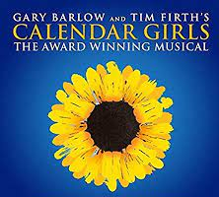
PBTC AUDITION FORM
Calendar Girls
You need to be a FULL MEMBER to audition
(A pre-payment of £10 must be paid by new members prior to the auditions. The balance to be paid if successful)
ACTING FEES OF £95 ARE DUE AT THE FIRST REHEARSAL

Name _________________________________________
E-Mail Address __________________________________
Are you on Facebook? Y/N (name on facebook_________________________)
Tel (mob) _______________________________________
I wish to audition for the following roles:
1. _______________________________
2. _______________________________
3. _______________________________
I will accept any part offered Y/N
Please can you indicate ALL Tuesday, Thursday, Friday or Sunday dates that you cannot make in the rehearsal period (January 4th – 30th April 2022, plus Monday 13th December 2021).
Please note this is an ensemble show and you will be needed for most rehearsals.
Dates I cannot attend

As well as the joy of performing on stage, our members also need to support in other ways. Please can you tick other jobs you can help us with?
Wardrobe Stage Manager
Back stage Props
Publicity / selling tickets Prompt at rehearsals / during the show
Set building / painting Lighting / Sound
Other (please state)

The Director will contact the cast as soon as casting is confirmed, via e-mail. The cast lit will also be published via the PBTC members e-mail account and the PBTC Facebook account

